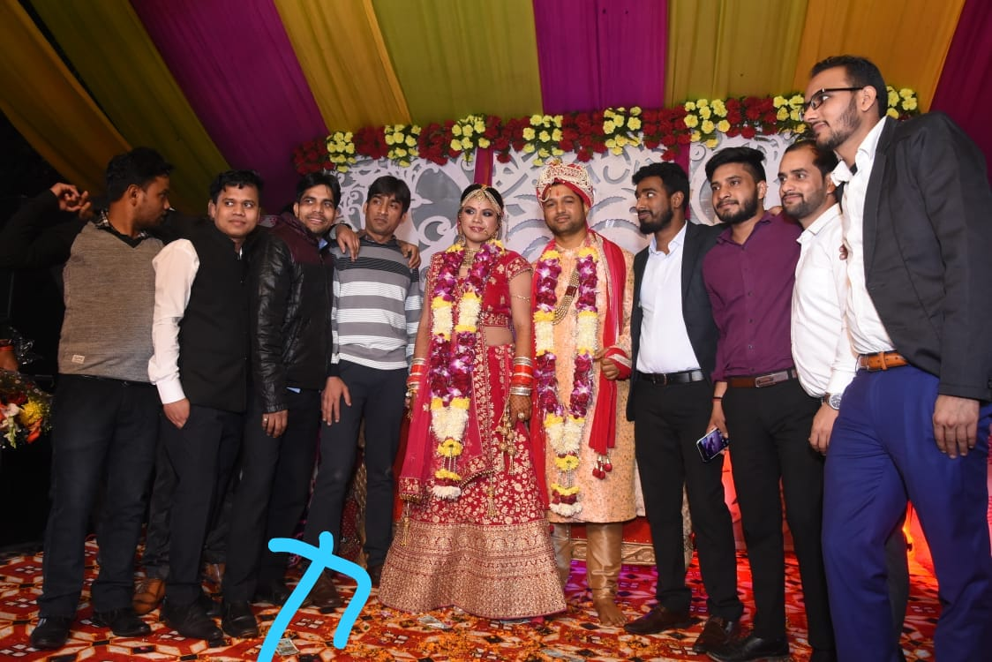

I am grateful for your true friendship.

Hope you birthday is amazing as you are my best friend!
From: Valleemployee.

